KFold and StratifiedKFold
Import Libraries

import numpy as np
import pandas as pd
import os
from sklearn.linear_model import LogisticRegression
from sklearn.neighbors import KNeighborsClassifier
from sklearn.model_selection import cross_val_score, StratifiedKFold, StratifiedShuffleSplit ,train_test_split, KFold
import warnings
warnings.filterwarnings("ignore")
Load Data Set
os.chdir('C:\\Noble\\Training\\Top Mentor\\Training\Data Set\\')
dataset=pd.read_csv('adult.csv')
display(dataset)

Dataset Details
dataset.info()

Check for Null Values
dataset.isnull().sum()

Convert Gender Male to 0 and Female to 1

dataset['gender']= dataset['gender'].map({"Male":0, "Female":1})
display(dataset)

Convert marital-status 0 and 1
dataset["marital-status"] = dataset["marital-status"].replace(['Never-married','Divorced','Separated','Widowed'],0)
dataset["marital-status"] = dataset["marital-status"].replace(['Married-AF-spouse','Married-civ-spouse', 'Married-spouse-absent'],1)
display(dataset)

Convert marital-status to Integer
dataset["marital-status"]=dataset["marital-status"].astype(int)
dataset.dtypes

Remove columns which are not important
dataset.drop(labels= ['workclass','education','occupation','relationship','race','native-country'],axis =1, inplace = True)

display(dataset)

Create Y
y = dataset['income']
y

Dataset as X
dataset = dataset.drop('income',axis=1)
display(dataset )

Train Test Split
x_train,x_test,y_train,y_test = train_test_split (dataset,y , test_size = 0.2, random_state= 42)
print (x_train.shape,x_test.shape,y_train.shape,y_test.shape)

Create the Model
models = []
models.append (('LR',LogisticRegression()))
models.append (('KNN',KNeighborsClassifier()))
print (models)

Create Logistic Regression in the Normal way

LR = LogisticRegression()
LR.fit(x_train, y_train)

Prediction
y_pred = LR.predict (x_test)
y_pred

Accuracy
from sklearn.metrics import accuracy_score
accuracy_score(y_test, y_pred)

Display Unique Values
print (y_test.value_counts())
print (pd.DataFrame(y_pred).value_counts())

Implement K Fold 10-Fold
result= dict()
for name, model in models:
kfold= KFold(n_splits=10)
cv_results = cross_val_score(model,x_train, y_train, cv= kfold, scoring ='accuracy')
result[name] = ( cv_results, cv_results.mean(), cv_results.std())

Display Accuracy

for key,value in result.items():
print ('Model Name :', key ,'\n Individual Accuracy\n',value[0], '\nMean:',value[1],'\nSTD:',value[2], '\n')

Create Stratified KFold
skresult= dict()
for name, model in models:
skfold= StratifiedKFold(n_splits=10)
skcv_results = cross_val_score(model,x_train, y_train, cv= skfold, scoring ='accuracy')
skresult[name] = ( skcv_results, skcv_results.mean(), skcv_results.std())

Display Accuracy
for s_key,s_value in skresult.items():
print ('Model Name :', s_key ,'\n Individual Accuracy\n',s_value[0], '\nMean:',s_value[1],'\nSTD:',s_value[2], '\n')

Create Stratified Shuffle Split

sskresult= dict()
for name, model in models:
sskfold= StratifiedShuffleSplit(n_splits=10)
sskcv_results = cross_val_score(model,x_train, y_train, cv= sskfold, scoring ='accuracy')
sskresult[name] = ( sskcv_results, sskcv_results.mean(), sskcv_results.std())

Display Accuracy
for s_key,s_value in sskresult.items():
print ('Model Name :', s_key ,'\n Individual Accuracy\n',s_value[0], '\nMean:',s_value[1],'\nSTD:',s_value[2], '\n')
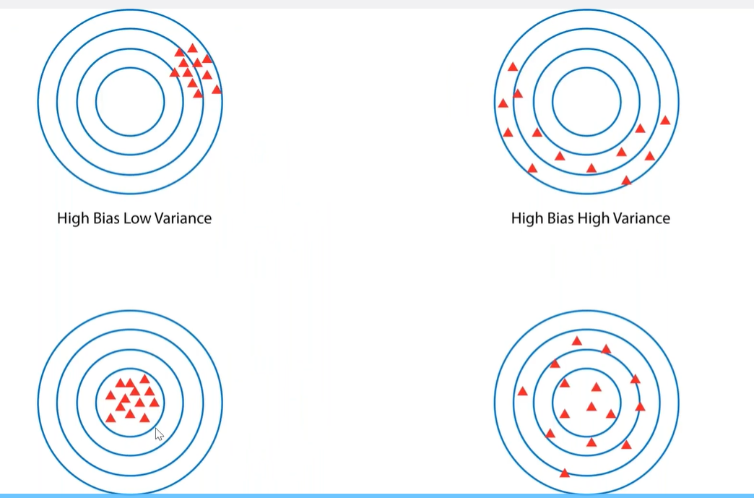
Low Bias Low Variance Low Bias High Variance

